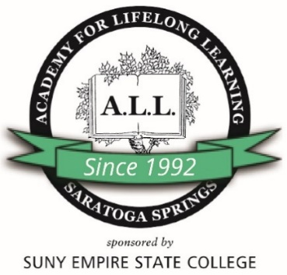

**ACADEMY FOR LIFELONG LEARNING**

**AT SARATOGA SPRINGS**

**MEMBERSHIP APPLICATION**

Name_______________________________________________________________________________

Address______________________________ City, State, Zip __________________________________

Email_____________________________________ Phone _

Cell Emergency contact/phone #___________­­_______________________

**ANNUAL MEMBERSHIP DUES**

**Annual Membership: Valid July 1 through June 30 $75.00 $____________**

I will be signing up for classes: Yes___ No___

For additional information, please call the Academy office at (518) 587-2100, ext. 2415.

I won’t be taking classes but I am joining to support the Academy ____

I am joining to participate in Academy activities other than classes ____

**GIFT GIVING** (If you would like to contribute beyond your annual membership dues)

A.L.L Annual Fund Contribution: $ ____________

Amount to be applied to:

General Fund $___________

Endowment Fund $___________

Pat Leonard Scholarship Fund $___________

**Total Enclosed** $_____________

Please make checks payable to: ***The Academy for Lifelong Learning.***

**Mail application and payment to:** A.L.L. Membership, Academy for Lifelong Learning,

SUNY Empire State College, 113 West Ave., Saratoga Springs, NY 12866.

**Annual Membership $75.00, Membership is for the fiscal year July 1st through June 30th**

Academy Membership entitles you to the following benefits:

· Eligibility to enroll in classes for the fall, winter and spring terms

. Continued connectivity to fellow Academy members and Academy staff

. Peace of mind and pride in knowing you're supporting a valuable community organization

· Eligibility to participation in the Academy’s Special Interest Groups (SIGS)

· Eligibility to participation in all special events, trips, and programs (Academy Extras)

· Free subscription to A.L.L. The News monthly newsletter and weekly E-newsletter

· Opportunity to be an Academy volunteer and serve on Academy committees

· Eligibility to submit work to “The Apple Tree,” the Academy’s literary and art journal

· Have a vote at the annual meeting held each June

Academy for Lifelong Learning at Saratoga Springs

113 West Avenue, Saratoga Springs, New York 12866-6069

518 587-2100 ext. 2390, [jeff.shinaman@esc.edu](mailto:jeff.shinaman@esc.edu) , [www.esc.edu/all](http://www.esc.edu/all)

Thank you for joining!

**ACKNOWLEDGMENT RELEASE AND WAIVER**

The undersigned does hereby acknowledge that he/she is participating in a program or activity by or through the ACADEMY FOR LIFELONG LEARNING AT SARATOGA SPRINGS/EMPIRE STATE COLLEGE, Two Union Avenue, Saratoga Springs, NY, referred to herein as "A.L.L.”

The undersigned does waive and release said A.L.L., A.L.L. staff, A.L.L. study group leaders, A.L.L. Executive Council, and Empire State College from any and all claims for injury or damage sustained by, through, or as a result of said activity, and does further hold said A.L.L., A.L.L. staff, A.L.L. study group leaders, A.L.L. Executive Council, and Empire State College harmless for any claims resulting therefrom.

Yes ____ No ____ A.L.L. may reproduce for publicity and news releases any photo images of me taken while participating in A.L.L. activities. *(If you’ve checked “NO,” it is YOUR responsibility to remove yourself from the photo before it is taken.)*

______________ _______________________________ ______________________________

Date Print Name Signature

In case of emergency, please contact:

_____________________________________ ______________________________

Print Name Phone

**Completed waiver must accompany Application.**